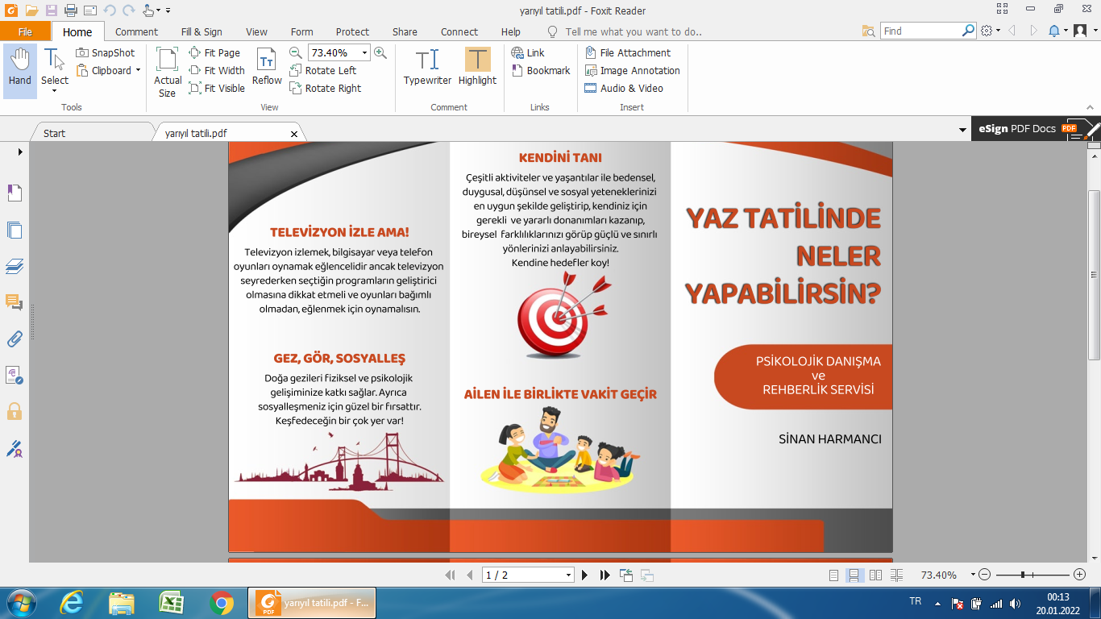

**MUSTAFA ÖZKAN**

**YARIYIL**

**TATİLİNDE**

**NELER YAPABİLİRSİN?**